Frequency Analysis and Categorical Data in R
For this activity, I used R to analyse the COVID-19 India dataset, containing 270 observations. The activity focused on creating binary and categorical variables, producing frequency tables and identifying patterns in the data. R provides a range of data structures and functions that allow data to be organised, transformed and analysed systematically (Simplilearn, 2017; Data Carpentry, 2020).
Death Reporting Analysis
I created a binary variable called has_deaths to identify whether deaths had been reported:
covid$has_deaths <- ifelse(covid$Deaths > 0, 1, 0)
table(covid$has_deaths)
The results showed:
- 245 records had no deaths reported.
- 25 records had one or more deaths reported.
I then converted the variable into a factor to make the categories easier to interpret:
covid$has_deaths <- factor(
covid$has_deaths,
levels = c(0, 1),
labels = c("No Deaths", "Deaths Reported")
)
table(covid$has_deaths)
This demonstrated how binary numerical values can be transformed into meaningful categorical labels for analysis.
Classification of Confirmed Cases
I calculated total confirmed cases by combining confirmed Indian and foreign national cases:
covid$total_confirmed <- covid$ConfirmedIndianNational +
covid$ConfirmedForeignNational
I then classified the results into four categories:
covid$case_level <- cut(
covid$total_confirmed,
breaks = c(-Inf, 0, 5, 15, Inf),
labels = c("No Cases", "Low Cases",
"Medium Cases", "High Cases")
)
table(covid$case_level)
prop.table(table(covid$case_level)) * 100
The analysis found that 177 records (65.56%) were classified as Low Cases, 61 (22.59%) as Medium Cases and 32 (11.85%) as High Cases. There were no records with zero confirmed cases.
State/Union Territory Frequency Analysis
I used a frequency table to determine how often each State/Union Territory appeared in the dataset:
state_freq <- table(covid$State.UnionTerritory)
state_freq_sorted <- sort(state_freq, decreasing = TRUE)
head(state_freq_sorted, 10)
The top 10 were:
Kerala (52), Delhi (20), Telengana (20), Rajasthan (19), Haryana (18), Uttar Pradesh (18), Tamil Nadu (15), Union Territory of Ladakh (14), Karnataka (13), and Maharashtra (13).
I also created a bar chart to visualise these results:
par(mar = c(10, 5, 4, 2))

barplot(
head(state_freq_sorted, 10),
main = "Top 10 States by Number of Daily Reports",
xlab = "",
ylab = "Number of Daily Reports",
las = 2
)

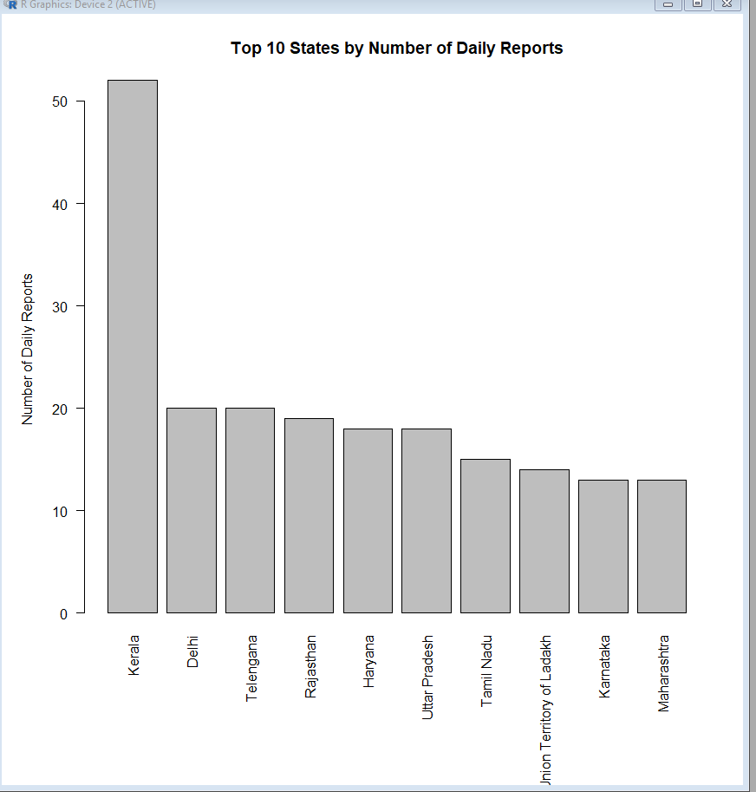
The chart shows that Kerala appeared most frequently in the dataset, with 52 daily records. This represents the frequency of reporting within the dataset rather than the total number of COVID-19 cases in each state.
Reflection and Learning Outcomes
This activity improved my understanding of how R can be used to transform, categorise and summarise data. In particular, using functions such as ifelse(), factor(), cut(), table() and prop.table() demonstrated how raw numerical data can be converted into meaningful categories and frequency distributions. Understanding R data structures and terminology provides an important foundation for manipulating and analysing datasets effectively (Simplilearn, 2017; Data Carpentry, 2020).
The activity also reinforced the importance of maintaining clear and well-organised data throughout the analysis process. Good research data management supports the transparency, reproducibility and reuse of research data, which are important principles of Open Science (Borghi and Van Gulick, 2022).
Overall, the activity supports the module learning outcomes by developing my understanding of statistical concepts used in Data Science and demonstrating how these methods can be applied to real-world data to identify patterns and support evidence-based decision-making.

Screenshot of R process
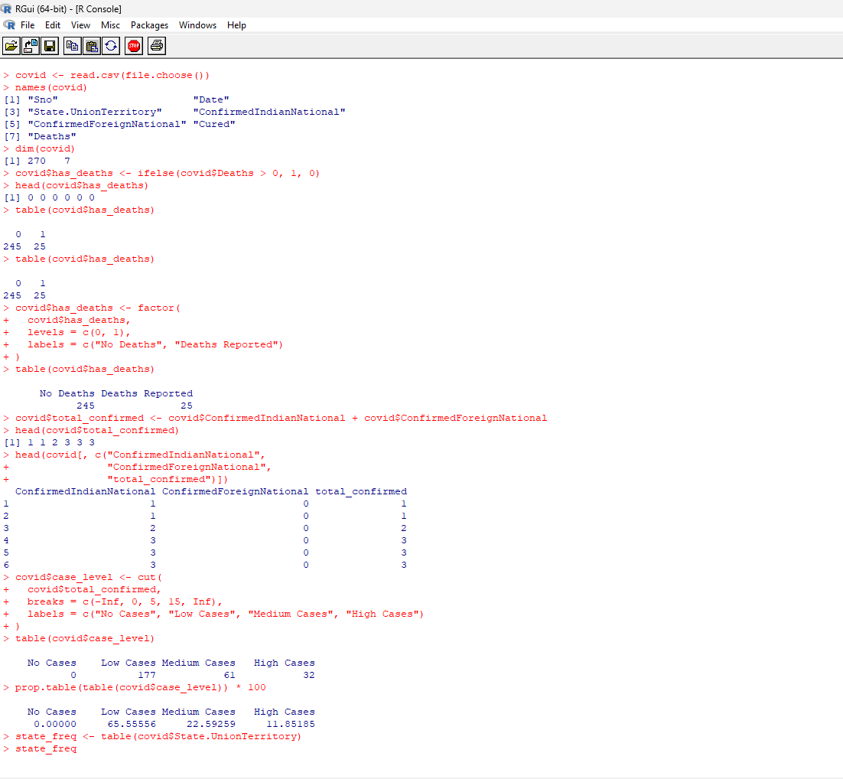

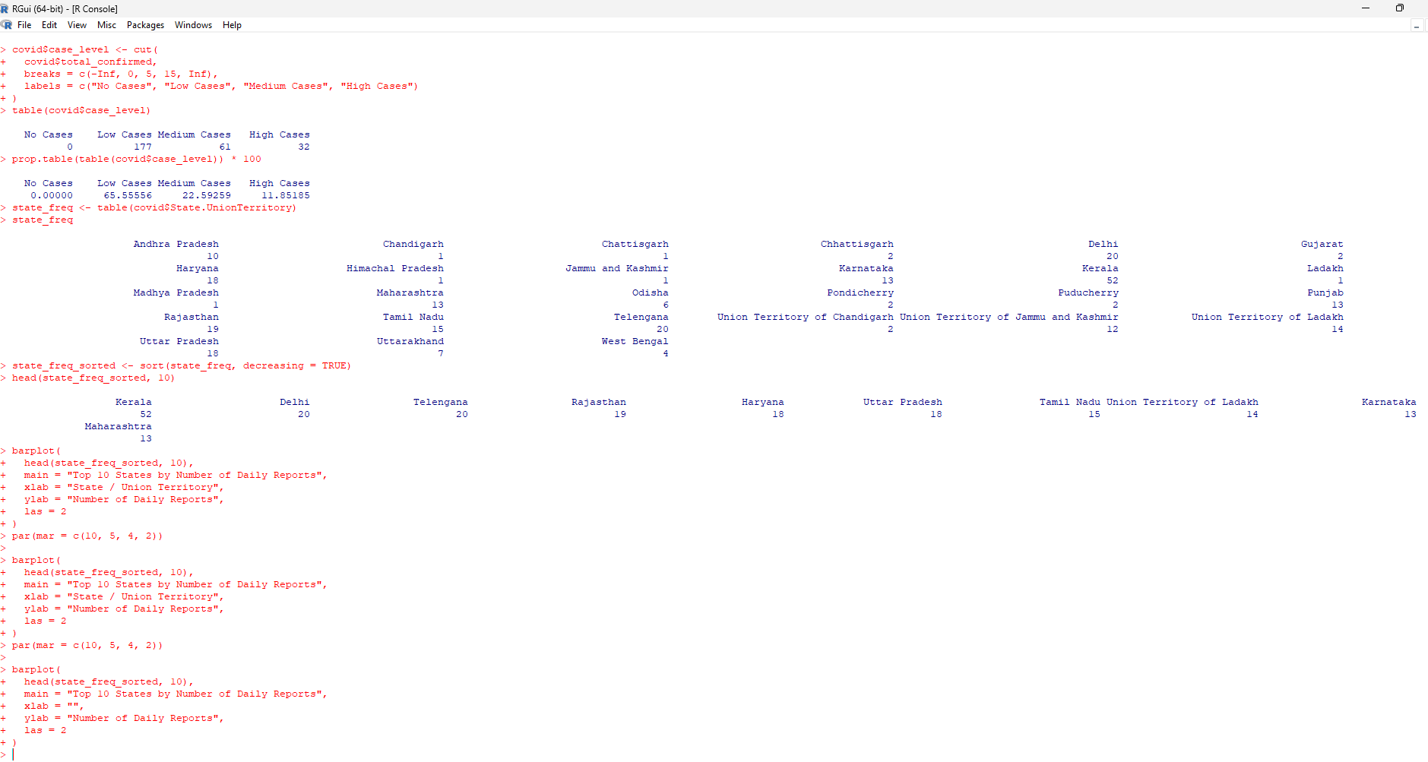

References
Borghi, J.A. and Van Gulick, A.E. (2022) ‘Promoting Open Science through research data management’, Harvard Data Science Review, 4(3). doi: 10.1162/99608f92.9497f68e.
Data Carpentry (2020) Intro to R and RStudio for Genomics: Glossary. Available at: Data Carpentry – R for Genomics (Accessed: 7 August 2026).
Simplilearn (2017) Data Science with R Tutorial | Lesson 4 – R Data Structures | Simplilearn [YouTube video]. 24 January. Available at: YouTube – R Data Structures tutorial (Accessed: 7 August 2026).

